Covington FFA
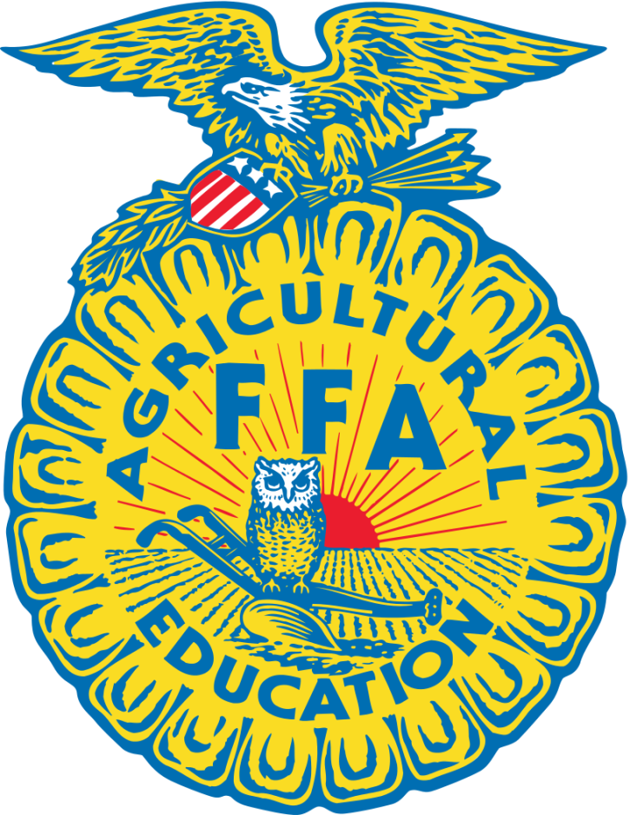
Booster Club

Membership Packet

Covington FFA Booster Club
Membership Packet

Founded in 1986, the Covington FFA Booster Club (CFFABC) is a nonprofit organization that works diligently to raise money to help and reward students who are interested in participating in livestock shows throughout the United States. It also promotes higher education by providing graduating seniors with scholarships in order to help with the cost of college tuition.

Each member of the booster club is asked to “earn” points in order to be eligible for benefits. Working at events, donating items and selling raffle tickets are just a few of the many ways to earn points throughout the year. A CFFABC “year” is effective beginning the 1st organizational meeting after the county sale and ending at that same time the following year.

Point Requirements

Families with 1 participating child: 750 points
Families with 2 participating children: 1,000 points
Families with 3 or more participating children: 1,250 points

The January meeting prior to the county show is the deadline for point earnings. Once the appropriate number of points is earned, meeting attendance requirements and concession stand quarters are met the participating child’s animals are eligible for funding at the Hill County Fair. This also entitles the child/children to receive breeding point rewards, Ag mechanic point rewards, and graduating seniors will be eligible for one of the CFFABC scholarships given each year. If all requirements are not earned by January deadline, members WILL NOT be eligible for funding rewards or scholarships.

Under special circumstances, members that have earned at least half of their required points by the January deadline can be approved for a hardship point grant. These members must have completed the hardship grant request and return it to the current Ag administrator for consideration. Approval must be made by the Ag administrator, and CFFABC Officers before points are granted.

Breeding Point Rewards

Many students have animals that are not market animals, therefore are not eligible for county sale funding. In order to reward these students for their hard work and dedication, each animal is given points depending on how they place at livestock shows.

At the conclusion of the year, the CFFABC officers make the recommendations to the members on how much money they think should be paid per breeding point. This is dependent on the type of project and the amount of funds available. Members then have the option of accepting or amending the recommendation. Money earned is paid to the student at the FFA Banquet.

Breeding point forms have to be filled out and turned in for approval.

Ag Mechanic Point Rewards

Many students have shop projects that are entered into competitions throughout the year. In order to reward these students for their hard work and dedication, each project is given points depending on how they place in their competitions. Then number of points given to an individual is determined by the Ag advisor, and totals are given to the Booster Club officers.
At the conclusion of the year, the CFFABC officers make the recommendations to the members on how much money they think should be paid per point. This is dependent on the type of project and the amount of funds available. Members then have the option of accepting or amending the recommendation. Money earned is paid to the student at the FFA Banquet.
Ag Mechanic point forms have to be filled out and turned in for approval.

Constitution and Bylaws

Article I Name:

Covington FFA Booster Club

Article II Objectives:
- To support and promote the FFA organization, FFA activities, and agricultural education on local and higher levels.
- To maintain the local Covington Show y supervising the operation of the show and auction.
- To raise money in order to assist FFA Booster Club members in the selling of their projects at the county show.
- To provide scholarships for graduating senior booster club members to assist them in their future goals.
- This organization is organized exclusively for charitable, religious, educational and or scientific purposes under section 501c (3) of the Internal Revenue Code.

Article III Membership:
- Membership shall be open to any parent of family member of past or present FFA members. Youth members must be in the 3rd grade or above.
- Businesses or outside individuals may also be members in the club.
- At the first meeting of the year, the members in attendance are allowed to vote upon paying the one dollar a year for dues.
- Membership being at the 1st meeting after by law changes.
- Members, or at least one representative for the member, are required to attend at least 3 meetings per year to maintain an active membership status.

Article V Officers:
- The elected offices shall serve a term of one year.
- The elected officers shall constitute the executive board of directors. It shall be the duty of this board to advise and make recommendations to the general membership with respect to the activities and business of the organization.
- Officers missing 3 unexcused general meetings or executive meetings may be removed from office and another election will be held to fill the position, as determined by the Ag advisor.
- The elected officers shall be:
- President
- Vice-President
- Secretary
- Treasurer
- Reporter
- Advisor(s)

- Duties of the officers:
- President
- Served as the official representative of the club.
- Set the agenda
- Preside over the meetings
- Coordinate with other officers to ensure that materials for the concession stand have been purchased.
- Vice-President
- Serve as the chairman in the absence of the president.
- In charge of all committees.
- Calculate and give a report at each meeting about how many points the members have earned.
- Keep a complete list of members.
- In charge of acquiring volunteers for the concession stands for the club.
- Coordinate with other officers to ensure that materials for the concession stand have been purchased.
- Secretary:
- Prepare and present the minutes at each meeting.
- Mail out newsletters before all meetings.
- Coordinate with other officers to ensure that materials for the concession stand have been purchased.
- Treasurer:
- Receive record and deposit club’s funds weekly.
- Present a monthly treasurer’s report.
- Tabulate and complete tax donation forms and mail them to those that have donated by January 31st.
- Coordinate with a designated tax professional to file tax forms with the IRS.
- Coordinate with other officers to ensure that materials for the concession stand have been purchased.
- Reporter
- Release news and information to social media and website.
- Coordinate with students and send thank you letters and other correspondence.
- Keep the web page up to date at all times.
- Post all posters and flyers to advertise our different fund raisers.
- Coordinate with other officers to ensure that materials for the concession stand have been purchased
- Advisor(s):
- Serve as a representative of the school and club.

Article VI Location of Offices:
- The principle office of the organization shall be the Agricultural Sciences Department at Covington High School.

Article VII Meetings:
- Meetings will be held at least 6 times a year. The president will set dates and locations.
- A quorum shall be declared when a minimum of three officers are present at any regular or called meeting.

Article VIII Check Signatures:
- The treasurer and/or president shall sign checks.

Article IX Amendments:
- These bylaws may be altered, amended, or repealed by a majority vote and/or approval of the board of directors once a year, at the February meeting.

Article X Dues:
- The membership dues have been amended to be effective beginning the 1st organizational meeting after the bylaw changes and ending at that same time the following year.
- Points will not accumulate until dues are paid.
- The dues for the voting membership are currently set at one dollar per member. An individual who pays their dues must wait until next meeting to be a voting member.

Article XI Concession Stands:
- All officers are in charge of running the concession stand.
- An officer will be designated before each game to be in charge of the concession stand for the night.
- At the end of each game, the designated officer will take inventory and inform other officers of what is needed for the next game. The inventory sheet will then be given to the person who is in charge of purchasing items for the next game.
- The Board will set the prices for the concession stand.
- For safety reasons, no students will be allowed in the grill or fryer area.
- Officers have the right to deny access to the concession stand area as deemed necessary.
- All items must be paid for at the time of purchase. No tabs are allowed.
- Any child under the age of 12 years old must be accompanied by a parent at all times. No children under third grade or are not members of the FFA Booster Club are not allowed in concession stand.
- 11 quarters must be worked by active members at football games as a requirement for the FFA Booster club.

Article XII Scholarships:
- Only graduating CISD seniors may apply.
- Applicants must be a current paid member of the Covington FFA Booster Club.
- Applicants must have earned their necessary points, met the meeting requirements, and work required concession stand quarters prior to the January meeting deadline.
- Applicants must exhibit a project at the county show unless a hardship has been approven.
- The Booster Club will award a maximum of 2 scholarships per year with amounts dependent on available funds.
- Funds will be split into two installments for use in the students first two consecutive semesters
- All documents required for payment must be turned into the Booster Club President or its advisor two weeks prior to the first day of fall classes.
- All second installment documents, proof of enrollment and transcripts must be turned in prior to January 15th for all spring semester classes.

Article XIII County Show:
- Funding is available for current and paid members only.
- The FFA Booster Club bids on projects entered into the Hill County sale from livestock.
- Members are only eligible for funding on one project per year.

The constitution and Bylaws are the Articles of our club. The constitution and bylaws is the only governing instrument of our organization. We have grouped them together to serve as our governing instrument.

2022/2023 Contact Information
Join CFFABC on Facebook for updates
Email us at cffaboosterclub@gmail.com
Visit our website @ www.cffabc.yolasite.com

President Vice President Treasurer
Stephanie Ownbey Paula Ratliff Sean Ratliff

Secretary Reporter Advisors
Jennifer Knox Michelle Gross Jack Swilley &
Riley Schmidt

Point System

The Purpose of the Point System:

The point system was established to enable the Covington FFA Booster Club to raise the excessively large amount of money necessary to support the Covington FFA Program.

Its sole purpose is to insure that the students, parents, guardians and community help raise the funds that are distributed as evenly and fairly as possible to the FFA club students.

It is believed that nothing in life is free and the FFA motto says it best:

Learning to Do
Doing to Learn
Earning to Live
Living to Serve

Article I

Members of households can earn points as long as they are current/paid members of the Covington FFA Booster Club.

Article II

Vice-President will keep records of all points earned.

Article III

Each family must have earned half of the points needed for their family, before hard luck is considered. A form must be completed and given to the Ag advisor.

Article IV

If special circumstances arise, the current Ag advisor will establish a special circumstance list and present it to the FFA Booster Club.

Article V

Points will be established by the current officers for each activity as the need arises.

Article VI

Points must be earned on or before the January meeting prior to the county show.

Point requirements:
- 1 child – 750 points
- 2 children – 1,000 points
- 3 or more children – 1,250 points

The following is a list of possible ways to acquire points. The Booster Club officers reserve the right to award points for other contributions to the club that are not listed below. Request for awarded points not listed below will need to be written and signed by the member. The board and Ag advisor will then award the points deemed necessary.
- Pay dues – 5 points
- Attend meetings – 10 points per meeting
- Club officers:
- President – 100 points
- Vice-president – 75 points
- Secretary – 75 points
- Treasurer – 75 points
- Reporter – 50 points
- Serve on a committee – 30 points
- Cleaning concession stand – 20 points per hour
(at the beginning and end of the season)
- Football concession stand – 20 points per quarter (each of the following also constitutes a quarter: set up before game, each quarter, clean up, half time and between games.)
- Hoot shoot workers – 30 points per hour
- Auction donations – depending on the $ value of the donation and determined by the officers.
- Project show/concession – 20 points (set up/break down)
- Project show concession – 20 points per hour
- Help with auction – 20 points per hour
- Covington Classic workers – 30 points per hour
- Help with the grooming, clipping and hauling of other people’s animals for shows – 20 points
- Food items -15 points per items ( bake sale)
- 12 cookies
- 12 brownies
- 12 cupcakes
- 1 pie or cake
(Donated for any types of meals or bake sales)
- Each hour worked at a ticket/bake sale – 20 points
- Donations or purchases made to the Booster Club – dependent on the $ value and determined by the officers.
- Sponsorship for buckles/ sponsorships for items for Hoot Shoot – 50 points

Breeding Point Request Form

Point system for breeding animals only (heifers, goats, horses, sheep, rabbits, and swine). To do the point system each person is responsible for their points, and they are to be turned into the FFA advisor after each show that is participated in. You may use the point system for each breeding animal you show. Remember local and area shows count too; Hico, Clifton, Hill County. The Covington show does not count.

Your Name:

Breed of Animal:

Date and Place of Show:

First Place 20 points

Second Place 18 points

Third Place 16 points

Fourth Place 14 points

Fifth Place 12 points

Showmanship 20 points plus any placing points

Grand Champion 15 points plus any place points

Reserve Grand Champion 10 points plus any placing points

Champion of a Breed 10 points plus any placing points

Reserve champion of a breed 5 points plus any placing points

Participation 10 points

Total Points:____________

Student signature: _______________________________

Ag Mechanic Request Form

Point system for Ag Mechanics is for shop projects only. To do the point system each person is responsible for their points, and they are to be turned into the FFA advisor after each show that is participated in. You may use the point system for each Ag Mechanic project you show. Remember local and area shows count too, Waco, San Antonio, Houston, Fort Worth and Hill County. The Covington show does not count.

Your Name:

Name of Project:

Date and Place of Show:

First Place 20 points

Second Place 18 points

Third Place 16 points

Fourth Place 14 points

Fifth Place 12 points

Showmanship 20 points plus any placing points

Grand Champion 15 points plus any place points

Reserve Grand Champion 10 points plus any placing points

Champion of a Division 10 points plus any placing points

Reserve Champion of a Division 5 points plus any placing points

Participation 10 points

Total Points: ___________

Student signature: ____________________________

Point Reward Request Sheet

I, ask that points be rewarded to the
Family for services described below.

Amounts of points requested:

Signature of requestor

For Office Use Only
Points awarded :

Signature of Advisor Date

Signature of CFFABC Officers Date

Hardship Point Grand Request

I, ask that points be rewarded to the
Family for services described below.

Amounts of points requested:

Signature of requestor

For Office Use Only
Points awarded:

Signature of Advisor Date

Signature of CFFABC Officers Date

Covington FFA Booster Club Membership Form
By joining the Covington FFA Booster Club, I agree that:
- I will abide by all rules and regulations set forth by the organization’s Constitution and Bylaws.
- I, or a representative of my student, will attend a minimum of 3 meetings and work a minimum of 11 quarters in the concession stand per year.
- I am aware of the points that my family must earn on or before the January meeting prior to the county show in order to be eligible for benefits.
Point Requirements:
Families with 1 child: 750 points
Families with 2 children: 1,000 points
Families with 3 or more children: 1,250 points
- I will try to the best of my ability to help all members of the Booster Club when needed.
- I will represent Covington ISD and Covington FFA with pride and respect.

Family Name Home Phone Number

Home Address City State Zip

Y/N Y/N Paid
Member Name Cell # e-mail text Facebook

Y/N Y/N Paid
Member Name Cell # e-mail text Facebook

Y/N Y/N Paid
Member Name Cell # e-mail text Facebook

Y/N Y/N Paid
Member Name Cell # e-mail text Facebook

Y/N Y/N Paid
Member Name Cell # e-mail text Facebook

Preferred Mode of Contact: (Circle one) E-mail Text Facebook

Signature: Date:

